E I G H T

Root Locus Techniques

SOLUTIONS TO CASE STUDIES CHALLENGES

**Antenna Control: Transient Design via Gain**

**a.** From the Chapter 5 Case Study Challenge:

G(s) =

Since Ts = 8 seconds, we search along - , the real part of poles with this settling time, for 180o. We find the point to be - 0.5+j6.9 with 76.39K = 7194.23, or K = 94.18. Second-order approximation is OK since third pole is much more than 5 times further from the imaginary axis than the dominant second-order pair.

**b.**

**Program:**

numg= 1;

deng=poly([0 -150 -1.32]);

'G(s)'

G=tf(numg,deng)

rlocus(G)

axis([-2,0,-10,10]);

title(['Root Locus'])

grid on

[K1,p]=rlocfind(G)

K=K1/76.39

**Computer response:**

ans =

G(s)

Transfer function:

1

-----------------------

s^3 + 151.3 s^2 + 198 s

Select a point in the graphics window

selected_point =

-0.5034 + 6.3325i

K1 =

6.0690e+003

p =

1.0e+002 *

-1.5027

-0.0052 + 0.0633i

-0.0052 - 0.0633i

K =

79.4469

>>

ans =

G(s)

Transfer function:

1

-----------------------

s^3 + 151.3 s^2 + 198 s

Select a point in the graphics window

selected_point =

-0.5000 + 6.2269i

K1 =

5.8707e+003

p =

1.0e+002 *

-1.5026

-0.0053 + 0.0623i

-0.0053 - 0.0623i

K =

76.8521

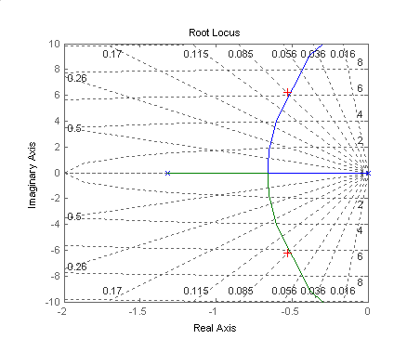

UFSS Vehicle: Transient Design via Gain

**a.** Push -K1 to the right past the summing junction yielding G(s) = , where K = 0.25K1. Combine the parallel feedback paths and obtain H(s) = (s+1). Hence, G(s)H(s) = . The root locus is shown below in (b). Searching the 10% overshoot line ( = 0.591;   □), we find the operating point to be -1.07 ± j1.46 where K = 3.389, or K1 = 13.556.

**b.**

**Program:**

numg= [1 0.437];

deng=poly([0 -2 -1.29 -0.193]);

G=tf(numg,deng);

numh=[1 1];

denh=1;

H=tf(numh,denh);

GH=G*H;

rlocus(GH)

pos=(10);

z=-log(pos/100)/sqrt(pi^2+[log(pos/100)]^2);

sgrid(z,0)

title(['Root Locus with ' , num2str(pos), ' Percent Overshoot Line'])

[K,p]=rlocfind(GH);

pause

K1=K/0.25

T=feedback(K*G,H)

T=minreal(T)

step(T)

title(['Step Response for Design of ' , num2str(pos), ' Percent'])

**Computer response:**

Select a point in the graphics window

selected_point =

-1.0704 + 1.4565i

K1 =

13.5093

Transfer function:

3.377 s + 1.476

---------------------------------------------

s^4 + 3.483 s^3 + 6.592 s^2 + 5.351 s + 1.476

Transfer function:

3.377 s + 1.476

---------------------------------------------

s^4 + 3.483 s^3 + 6.592 s^2 + 5.351 s + 1.476

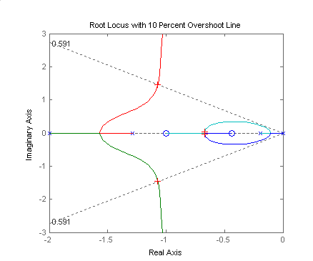

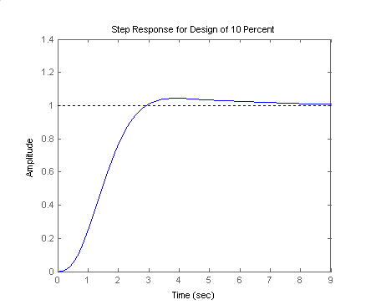

Answers to Review Questions

**1.** The plot of a system's closed-loop poles as a function of gain

**2. (**(1) Finding the closed-loop transfer function, substituting a range of gains into the denominator, and factoring the denominator for each value of gain. (2) Search on the s-plane for points that yield 180 degrees when using the open-loop poles and zeros.

**3.** K = 1/5

**4.** No

**5.** At the zeros of G(s) and the poles of H(s)

**6.** (1) Apply Routh-Hurwitz to the closed-loop transfer function's denominator. (2) Search along the imaginary axis for 180 degrees.

**7.** If any branch of the root locus is in the rhp, the system is unstable.

**8.** If the branch of the root locus is vertical, the settling time remains constant for that range of gain on the vertical section.

**9.** If the root locus is circular with origin at the center

**10.** Determine if there are any break-in or breakaway points

**11.** (1) Poles must be at least five times further from the imaginary axis than the dominant second order pair, (2) Zeros must be nearly canceled by higher order poles.

**12.** Number of branches, symmetry, starting and ending points

**13.** The zeros of the open loop system help determine the root locus. The root locus ends at the zeros. Thus, the zeros are the closed-loop poles for high gain.

SOLUTIONS To Problems

**1.**

**a.** No: Not symmetric; On real axis to left of an even number of poles and zeros

**b.** No: On real axis to left of an even number of poles and zeros

**c.** No: On real axis to left of an even number of poles and zeros

**d.** Yes

**e.** No: Not symmetric; Not on real axis to left of odd number of poles and/or zeros

**f.** Yes

**g.** No: Not symmetric; real axis segment is not to the left of an odd number of poles

**h.** Yes

**2.**









**3.**

**a**. There are two asymptotes with  and real axis intersection . The break-in and breakaway points are obtained by finding . Obtaining and solving for the roots of the numerator we get: . So the root locus looks as follows:

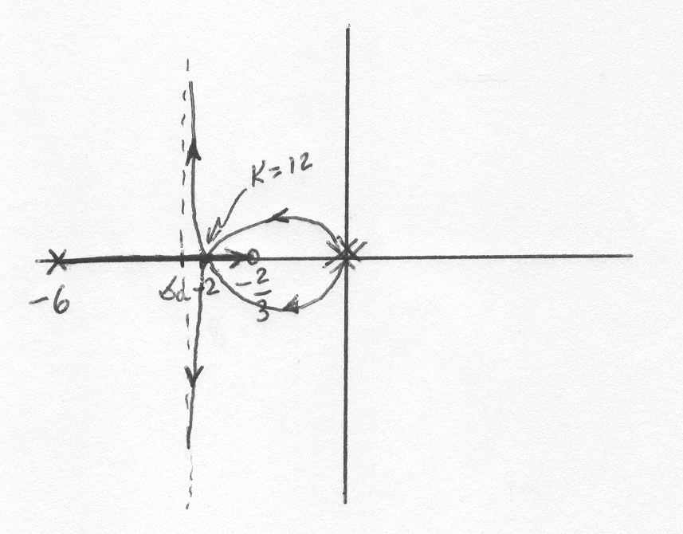

**b**. We can obtain  from , resulting in . Note that the open loop zero will appear as a closed loop zero, so the closed loop transfer function is 

**4.**

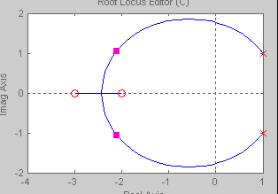

Breakaway:  = -2.43 for K = 52.1

**5.**

The root locus is:

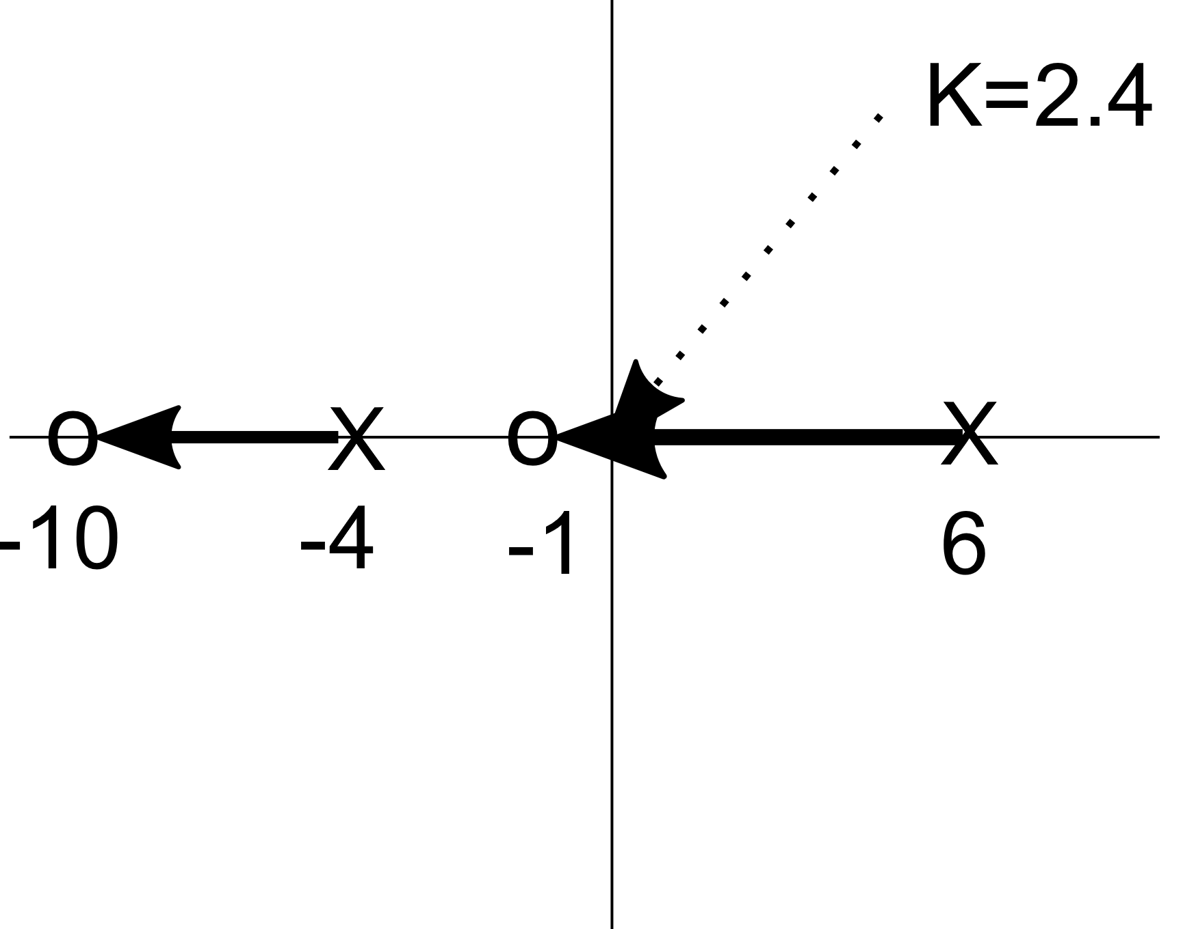

There are no break-in or breakaway points which can be verified by computing , or , or which has only complex conjugate roots not on the locus.

To find the range of for closed loop stability we use the characteristic equation

Which can be rewritten as . The Routh array is

|  |  |  |
| --- | --- | --- |
|  |  |  |
|  |  |  |
| 1 |  |  |

The first row demands ; the second and the third . The intersection of the three requirements is .

**6.**

Convert the denominator to the following form:  and thus identify .

Plotting the root locus yields

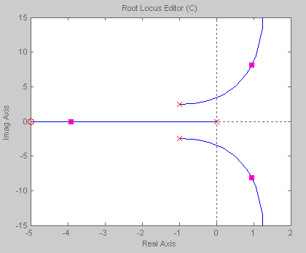



**7.**

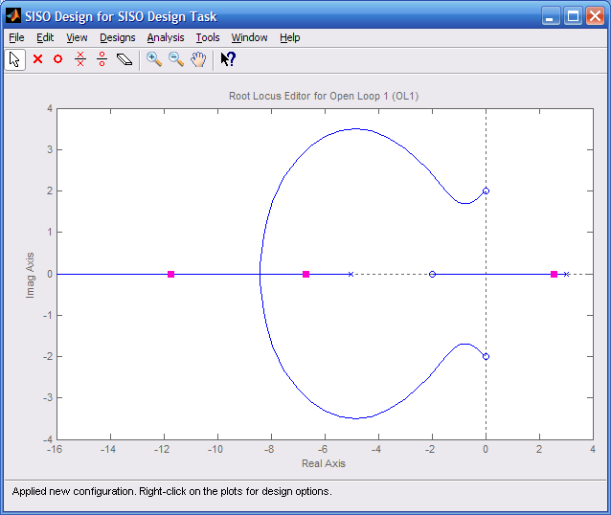

Closed-loop poles will be in the left-half-plane when rhp pole reaches the origin, or.

**8.**

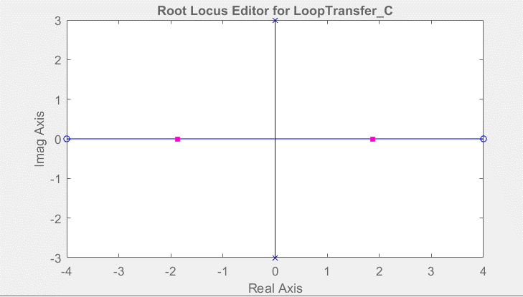

Closed-loop poles will be in the right-half-plane for  (gain at the origin). Therefore, stable (although marginally stable) for ; unstable for .

**9.**

**System 1:**



**a.** Breakaway:  = 1.41 for K = 0.03; Break-in:  = -1.41 for K = 33.97.

**b.** Imaginary axis crossing at j1.41 for K = 1. Thus stable for K > 1.

**c.** At break-in point, poles are multiple. Thus, K = 33.97.

**d.** Searching along 1350 line for 1800, K = 5 at 1.414  1350.

**System 2:**



**a.** Break-in:  = -1.41 for K = 28.14.

**b.** Imaginary axis crossing at j1.41 for K = 0.67. Thus stable for K > 0.67.

**c.** At break-in point, poles are multiple. Thus, K = 28.14.

**d.** Searching along 1350 line for 1800, K = 4 at 1.414  1350.

**10.**

**a.**



Root locus crosses the imaginary axis at the origin for K = 6. Thus the system is stable for K > 6.

**b.**



Root locus crosses the imaginary axis at j0.65 for K = 0.79. Thus, the system is stable for K < 0.79.

**11.**

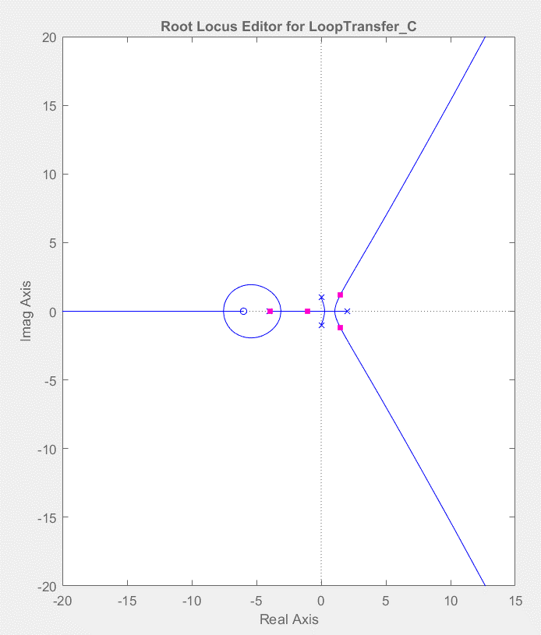

The system is closed loop unstable for all . The value of at which there will be only two roots in the RHP can be found by calculating the point at which the real RHP pole crosses the origin. Namely

It can readily be seen that there will be only two RHP roots for .

**12.**



Root locus crosses the imaginary axis at j6.3 with a gain of 517. Real axis breakaway is at –2.0 at a gain of 36.0. Real axis intercept for the asymptotes is . The angles of the asymptotes are: , , . Some other points on the root locus are (see figure):

 = 0.401: -1.37 - j3.14, K = 121

 = 0.602: -1.66 + j2.21, K = 74.2

**13.**

**a.** Root locus crosses the imaginary axis at at *K* = 52.

**b.** Since the gain is the product of pole lengths to -5,  .

**14.**

**a.**



**b.** ;

**c.** The characteristic equation is

The corresponding Routh array is:

|  |  |  |  |
| --- | --- | --- | --- |
|  | 1 | 34 |  |
|  | 11 |  |  |
|  |  |  |  |
|  |  |  |  |
|  |  |  |  |

The system will have poles on the axis when .

**d.** We calculate the breakaway points from where ; ; ; giving which has roots at , , . The only viable breakpoint is -0.4915. We use the characteristic equation to solve for .

**15.**

Assume that root locus is epsilon away from the asymptotes. Thus, a = ≈ -1; Angle = = , . Hence  = 7. Checking assumption at –1 ± j100 yields -180o with K = 9997.02.

**16.**



**a.** The breakaway points are found from or

or

whose roots are 10.662, -2.5, 2.4, -0.56; the latter two being on the root locus.

**b**. The characteristic equation is

or

The Routh array is

|  |  |  |
| --- | --- | --- |
|  | 1 |  |
|  |  |  |
|  |  |  |
| 1 |  |  |

The intersection with the jω-axis will occur when the third row is 0, namely K=1. At this point we can find the intersections by solving ; which gives .

**c.**

From the Routh Hurwitz table., the last row demands , which in turn satisfies the second row. Thus the third row will be positive if The range for closed loop stability is .

**d.**  Searching 120°, we find the point -0.366±j0.637 for K=0.41

**17.**



**a.** Asymptotes: int = = - ; Angle = = , , ,

**b.** Breakaway: -1.38 for K = 1 and -3.62 for K = 1

**c.** Root locus crosses the imaginary axis at ±j2.24 for K = 126. Thus, stability for K < 126.

**d.** Search 0.7 damping ratio line (134.427 degrees) for 1800. Point is 1.4171□ =

- 0.992 ± j1.012 for K = 10.32.

**e.** Without the zero, the angles to the point ±j5.5 add up to -265.074o. Therefore the contribution of the zero must be 265.074 - 180 = 85.074o. Hence, tan 85.074o = , where - zc is the location of the zero. Thus, zc = 0.474.



**f.** After adding the zero, the root locus crosses the imaginary axis at ±j5.5 for K = 252.5. Thus, the system is stable for K < 252.5.

**g.** The new root locus crosses the 0.7 damping ratio line at 2.7318134.427o for K = 11.075 compared to 1.4171134.427o for K = 10.32 for the old root locus. Thus, the new system's settling time is shorter, but with the same percent overshoot.

**18.**



**19.**

**a.**



**b.** Root locus crosses 20% overshoot line at 1.8994  117.126o = - 0.866 ± j1.69 for K = 9.398.

**c.** Ts = = 4.62 seconds; Tp = = 1.859 seconds

**d.** Root locus crosses imaginary axis at ±j3.32 for K = 60. Therefore stability for K < 60.

**e.** Other poles with same gain as dominant poles:   = -4.27

**20.**

**a**



**b.**

**c.** The characteristic equation is

The corresponding Routh array is:

|  |  |  |  |
| --- | --- | --- | --- |
|  | 1 | K+59 |  |
|  | 13 |  |  |
|  |  |  |  |
|  |  |  |  |
|  |  |  |  |

So the system is closed loop stable when .

1. The breakaway points are found from or

Which has the roots: 4.324, 1.6573, -3.4207, -4.5698 and -1.4908. Only the last two roots are in the root locus.

**e.** For 20% overshoot, the Equation yields ** = 0.456. Searching along this damping ratio line, we find the 1800 point at –0.566 + *j*1.09 where *K* = 12.5.

**f.** –0.566 + *j*1.09

**g.** Second-order approximation not valid because of the existence of closed-loop zeros in the rhp.

**h.**

**Program:**

s=tf('s');

G=12.5*(s^2-2*s+2)/(s^4+13*s^3+59*s^2+107*s+60);

T=G/(1+G);

step(T)

**Computer response:**



Simulation shows over 35% overshoot and nonminimum-phase behavior. Second-order approximation not valid.

24. • (Fall 1970, Exam 1, #3, design for gain)

21**21.**

**a.** Draw root locus and minimum damping ratio line.



Minimum damping ratio is  = cos (180 - 145.55) = cos 34.45o = 0.825. Coordinates at tangent point of  = 0.825 line with the root locus is approximately –1 + j0.686. The gain at this point is 0.32.

**b.** Percent overshoot for  = 0.825 is 1.019%.

**c.** Ts = = 4 seconds; Tp = = 4.57 seconds

**d.** Second-order approximation is not valid because of the two zeros and no pole-zero cancellation.

**22.**

Since the problem stated the settling time at large values of , assume that the root locus is approximately close to the vertical asymptotes. Hence, . Since specified sec, . The root locus is shown below



**23.**

The design point is – 0.6 ± j1.2. Excluding the pole at – , the sum of angles to the design point is – 156.08o. Thus, the contribution of the pole at –  is 156.08 – 180 = – 23.92o.

The following geometry applies:



Hence,  Thus ** = 3.305. Adding this pole at – 3.305 yields 180o at –  0.6 ± j1.2 with *K* = 51.8.

**24.**

**a.**



**b.** Searching along the 10% overshoot line (angle = 126.239o), the point - 0.7989 + *j*1.0898 yields 180o for K = 81.74.

**c.** Higher-order poles are located at approximately –6.318 and –7.084. Since these poles are more than 5 times further from the imaginary axis than the dominant pole found in (b), the second-order approximation is valid.

**d.** Searching along the imaginary axis yields 180o at *j*2.53, with *K* = 394.2.   
Hence, for stability, 0 < *K* < 394.2.

**25.**

**a.** For a peak time of 1s, search along the horizontal line, Im =  Tp  to find the point of

intersection with the root locus. The intersection occurs at –2 ± j at a gain of 11. 

 

**b.**

**Program:**

numg=11*[1 4 5];

deng=conv([1 2 5],poly([-3 -4]));

G=tf(numg,deng);

T=feedback(G,1);

step(T)

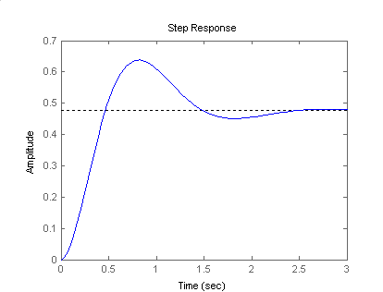

**26.**

**a.**

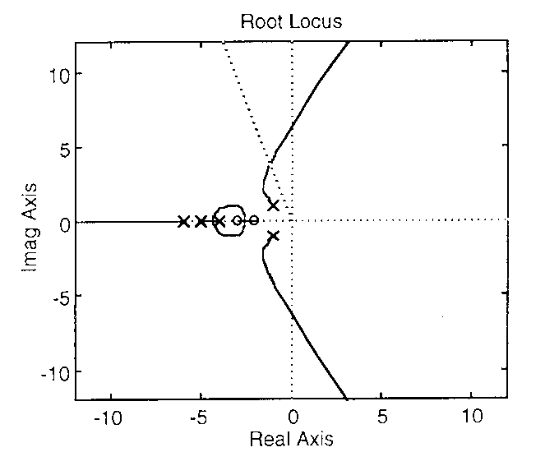

**b.** Searching the j axis for 180o, we locate the point j6.29 at a gain of 447.83.

**c.** Searching for maximum gain between -4 and -5 yields the breakaway point, -4.36. Searching for minimum gain between -2 and -3 yields the break-in point, -2.56.

**d.**



To find the angle of departure from the poles at -1±j1: - - 2 - 3 + 4 + 5 - 6 - 900   
= - tan-1(1/5) - tan-1(1/4) - tan-1(1/3) + tan-1(1/2) + tan-1(1/1) - 6 - 90o = 1800 . Thus, 6 = - 242.22o

**e.** Searching along the  = 0.3 line ( = 180 - cos-1() = 107.458o) for 180o we locate the point 3.96  107.458o = -1.188±j3.777. The gain is 127.133.

**27.**

a.

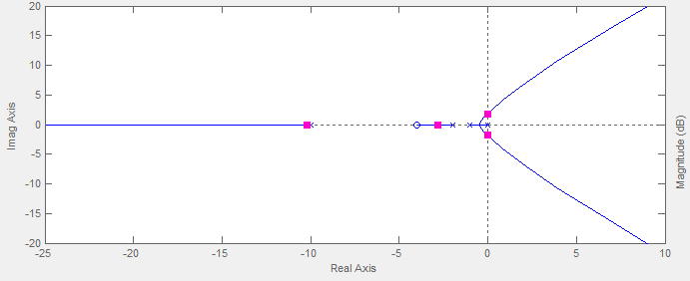

1. To find the jω crossing we will use Routh Hurwitz. The characteristic equation can be written as



The Routh array is

|  |  |  |  |
| --- | --- | --- | --- |
|  |  |  |  |
|  |  |  |  |
|  |  |  |  |
|  |  |  |  |
| 1 |  |  |  |

For closed loop stability, the fifth row demands , the 3d row ; satisfying these requirements the 4th row will be positive as long as . Thus the system will have roots in the jω axis when . Substituting this value, we get a row of zeros so the poles are located at the solution of  ; namely .

1. The breakaway points are obtained from the solution of or , which has roots  ,  and  the breakaway point occurring at the latter. At this point .
2. Searching for the crossing of the ξ=0.3 line ()for  we locate the point , when .

**28.**

**a.**



**b.** Searching the *j* axis for 180o, we locate the point *j*1.69 at a gain of 4.249.

**c.** Searching between -2 and -3 for maximum gain, the breakaway is found at -2.512.

**d.**



To find the angle of arrival to the zero at 2 + *j*2:



Solving for **1, the angle of arrival is **1 = –191.50.

**e.** The closed-loop zeros are the poles of *H(s)*, or –1 ± *j*2.

**f.** Searching the * *   = □) for 180o, we find the point

= -0.6537+*j*1.705. The gain, *K* = 0.8764.

**g.** Higher-order poles are at –2.846 ± j1.731. These are not 5 times further than the dominant poles. Further, there are closed-loop zeros at –1 ± *j*2 that are not cancelled any higher-order poles. Thus, the second-order approximation is not valid.

**29.**





**a.** As could be seen from the zoomed graph, the root locus crosses the imaginary axis at *j*2.76 with *K* = 5940. Therefore, the system is stable for 0 < *K* < 5940.

**b.** Search the 0.707 damping ratio line for 180o and find –0.978 + *j*0.978 with *K* = 1090.

**c.**  Assume critical damping where root locus breaks away from the real axis. Locus breaks away at –1.13 with K = 690.

**30.**

**Program:**

numg=1;

deng=poly([0 -3 -7 -9]);

numh=[1 30];

denh=[1 20 225];

G=tf(numg,deng)

Gzpk=zpk(G)

H=tf(numh,denh)

rlocus(G*H)

pause

K=0:10:1e4;

rlocus(G*H,K)

sgrid(0.707,0)

axis([-2,0.5,-5,5]);

pause

for i=1:1:3;

[K,P]=rlocfind(G*H)

end

T=feedback(K*G,H)

step(T)

**Computer response:**

G =

1

------------------------------

s^4 + 19 s^3 + 111 s^2 + 189 s

Continuous-time transfer function.

Gzpk =

1

-------------------

s (s+9) (s+7) (s+3)

Continuous-time zero/pole/gain model.

H =

s + 30

----------------

s^2 + 20 s + 225

Continuous-time transfer function.



Select a point in the graphics window



selected_point =

-0.9729 + 0.9783i

K =

1.0891e+03

P =

-9.9610 +11.1994i

-9.9610 -11.1994i

-8.5608 + 1.6058i

-8.5608 - 1.6058i

-0.9782 + 0.9799i

-0.9782 - 0.9799i

Select a point in the graphics window

selected_point =

0.0030 + 2.7484i

K =

5.9000e+03

P =

-9.7971 +11.2966i

-9.7971 -11.2966i

-9.7016 + 3.2277i

-9.7016 - 3.2277i

-0.0013 + 2.7518i

-0.0013 - 2.7518i

Select a point in the graphics window

selected_point =

-1.1295 + 0.0155i

K =

688.7886

P =

-9.9753 +11.1923i

-9.9753 -11.1923i

-8.3945 + 1.2181i

-8.3945 - 1.2181i

-1.1302 + 0.0155i

-1.1302 - 0.0155i

T =

688.8 s^2 + 1.378e04 s + 1.55e05

---------------------------------------------------------------------

s^6 + 39 s^5 + 716 s^4 + 6684 s^3 + 28755 s^2 + 4.321e04 s + 2.066e04

Continuous-time transfer function.

The step response for the critically damped case is shown below:



**31.**

**a.** Search jω=j5 for 180°and find  with  .

**b.** 

**c.** A settling time of 0.8 sec yield a real part of -5. Thus if the zero is at the origin  , which yields complex poles with -5 as the real part. At the design point  ,  .

**32.**

**a.** Searching along n = -1 for 180o, find –1 + j2.04 with K = 170.13.

**b.** Assume critical damping when root locus breaks away form the real axis. Searching for maximum gain, the breakaway point is at -1.78 with K = 16.946.

**33.**

The damping ratio corresponding to the required percent overshoot is:

** = =  = 0.45;

The following MATLAB M-file was written to plot the root locus; zoom it to find the gain *K* at that value of ** , then plot the closed-loop unit-step response, *c(t).*

numg = [1 0.02];

deng = poly([0 0 -4 -10 -25]);

G = tf(numg, deng);

rlocus(G);

title('Full Root Locus')

pause

axis ([-5, 0, -1, 6]);

z=0.45;

sgrid(z,0)

title('Root Locus Zoomed-in for Dominant Poles at a 0.45 Damping Line')

[K1,p]=rlocfind(G);

pause

K = K1;

T=feedback(K*G,1); %T is the closed-loop TF of the system

T=minreal(T);

step(T);

grid

ylabel('Unit-Step Response, c(t)')

title('Unit-Step Response at K = K1')

The full root-locus obtained is shown below, followed by the zoomed-in root locus and the unit-step response with all of the requested important characteristics marked on it.

For ** = 0.45, *K* = 2,183.8 and the dominant poles were found to be at –1.2263 ± 2.4239i.





**34.**

1. The characteristic equation is  or 

The Routh array is

|  |  |  |
| --- | --- | --- |
|  | 1 |  |
|  |  |  |
| 1 |  |  |

It follows that 

1. The locus for  is

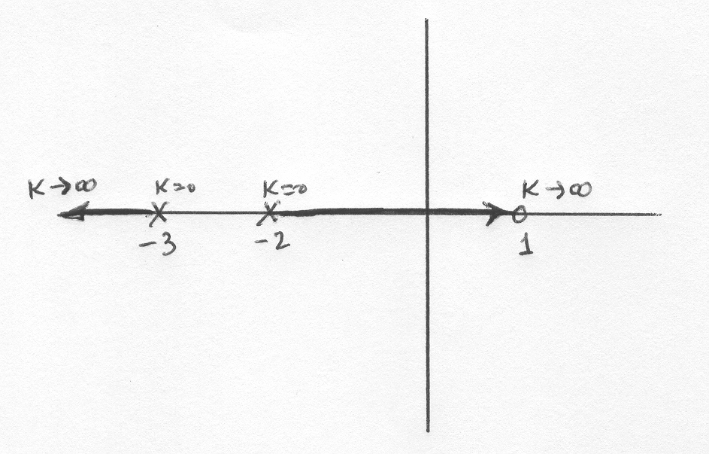

1. To find the break-in, breakaway points let . Then calculate 

The roots of the numerator are 

The locus for  is

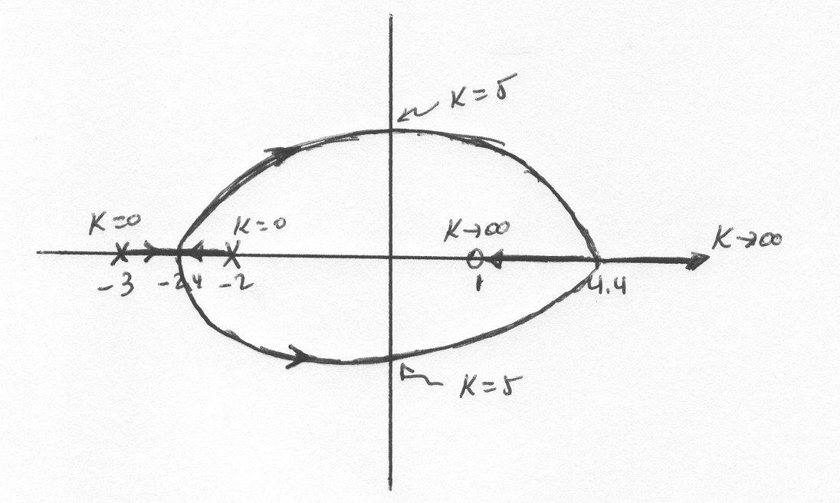

1. The smallest settling time for the system will occur when both roots are as far away as possible to the left of the  axis. This will happen when the system has identical roots at -2.4641. To find the value of K we use the characteristic equation

. Solving for  we get 

1. The proportional error constant 

Then 

1. The system in this case is critically damped, the settling time .The step response will approximately be:

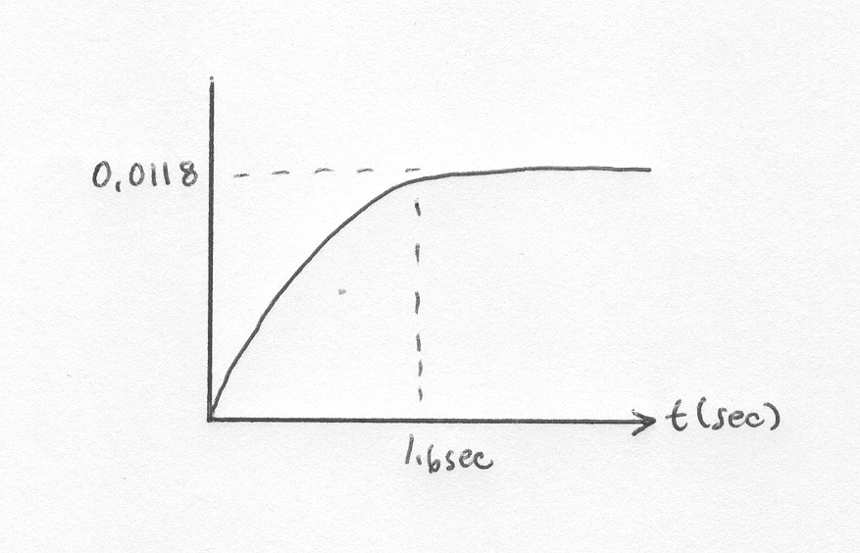

**35.**

**a**. The open loop transmission is .

There are two asymptotes with and angles 

To find the breakaway points let . Then , so the breakaway points occur when . The gain at this point is given by the solution of  or 

It is obvious from the figure that the system is unstable for all values of .

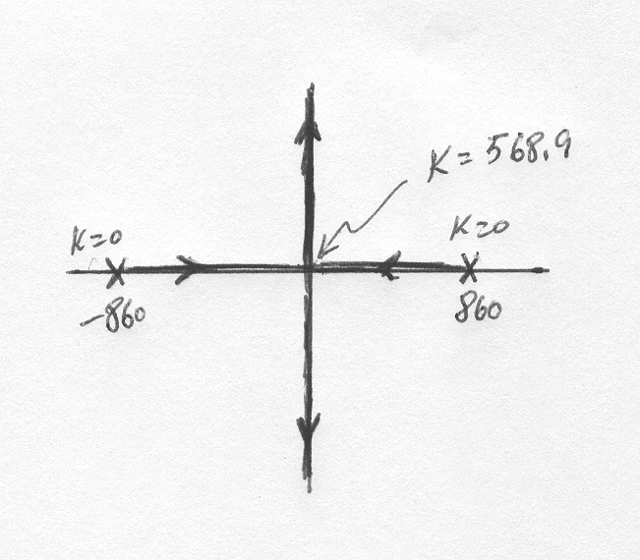

1. The open loop transmission is .

There are two asymptotes with  and angles 

To find the breakaway points let .

Then  The numerator has two complex conjugate solutions, and a real . The gain at this point is given by the solution of  or 

We use Routh-Hurwitz to find the range of K for which the system is closed loop stable. Let  or 

The Routh array is:

|  |  |  |
| --- | --- | --- |
|  | 1 |  |
|  | 1000 |  |
|  |  |  |
| 1 |  |  |

The dominant requirement given by the fourth row: 

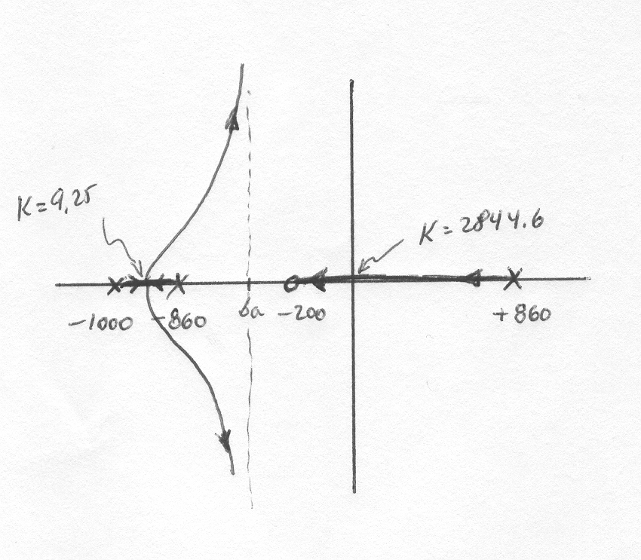

**36.**

1. After substituting numerical values 

The system’s characteristic equation is:

 or 

The Routh array is

|  |  |  |
| --- | --- | --- |
|  | 1 |  |
|  |  |  |
| 1 |  |  |

From which we get 

1. The characteristic equation cannot be written in the form 
2. Solving for the two roots we get 

A simple script that will plot the root locus is

>> v=linspace(0,4,100000);

>> s1 = (-0.5+sqrt(-3.08*v.^2+49))/2;

>> s2 = (-0.5-sqrt(-3.08*v.^2+49))/2;

>> plot(real(s1),imag(s1),real(s2),imag(s2))



**37.**

1. The system’s characteristic equation is found by calculating . This results in 

Which can be manipulated into

 or 

1. There are two asymptotes with  and real axis intersection .

To find the break in-breakaway points let

, then





The numerator of this expression has roots at 

The root locus is:

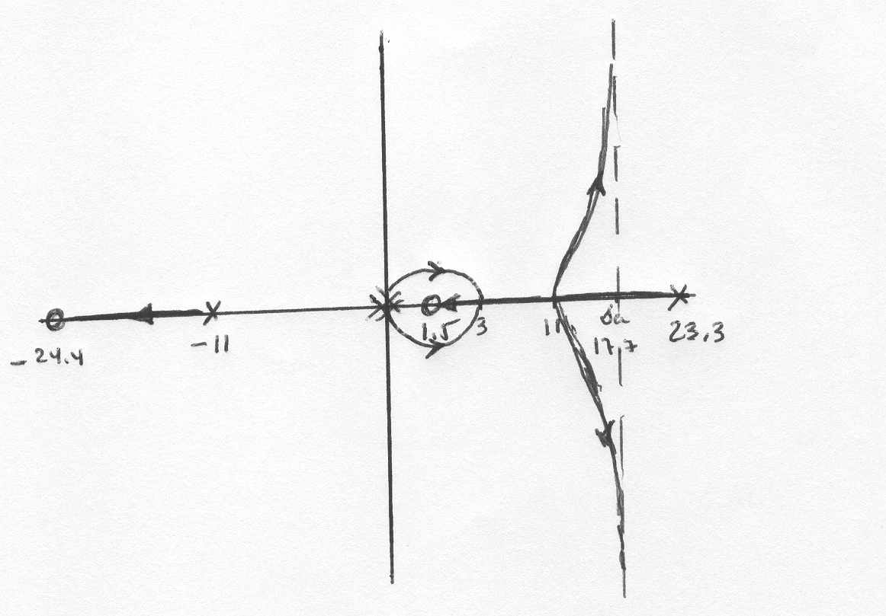

1. For any value of there are always closed loop poles in the RHP.

**38.**

1. Using Mason’s rule it can readily be found that (with d=0) the open loop transmission from  to  is



So the system’s characteristic equation is:



or



1. Substituting numerical values the characteristic equation becomes



The Routh array is

|  |  |  |
| --- | --- | --- |
|  |  | 73.7375m |
|  |  | 2.39125 |
|  |  |  |
| 1 | 2.39125 |  |

To have all the first column positive it is required that

 and . It follows that

 due to physical restrictions in the capacitance.

The characteristic equation can also be expressed as

 or .

There are no asymptotes. The break-in and breakaway points are calculated by first obtaining . Then differentiating, 

 The roots of the numerator are 

The value of  at -9030.7 is obtained fromgiving 

The root locus is:

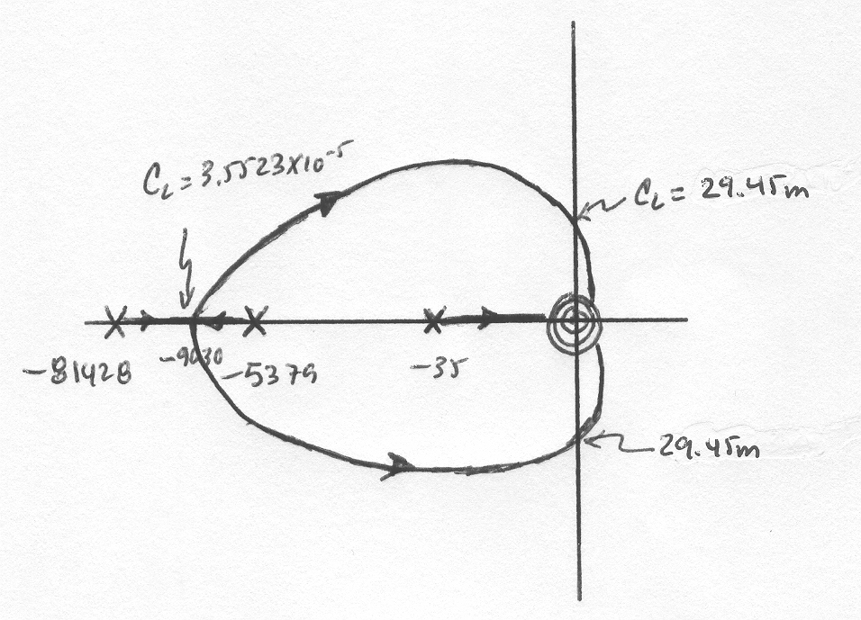

**39.**

1. Substituting values we have

, and

The systems characteristic equation is

Which can be rewritten as:

or

There are 3 asymptotes with a real axis intersection at

The breakaway points are found by defining

and . Then ;

Then becomes

That has roots at . The only solution in the locus is -0.2703.

The roots locus is:

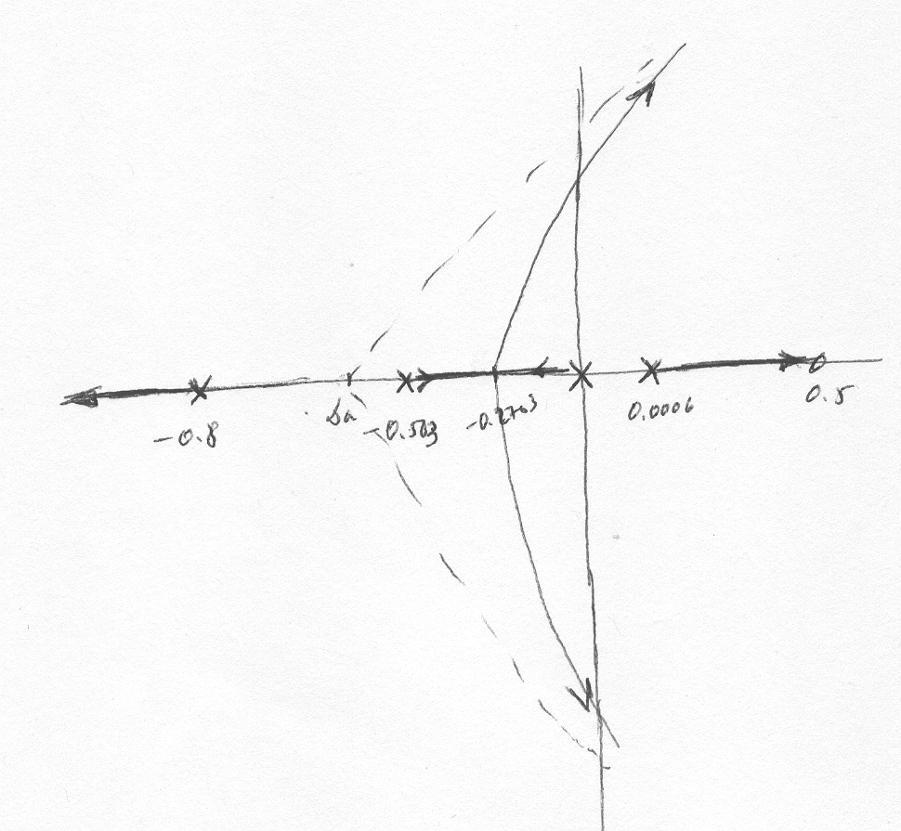

1. The system is unstable for all values of K, although with relatively large time constants for small K. It is very unlikely that the driver-train system is unstable.

**40.**

1.  & 

Hence: 

= 

Thus:  =

= 

1. The transfer function of the forward loop, *KG*(s):



The transfer function of the feedback loop is given by: .

The system’s characteristic equation is:



Or equivalently

= 0

The following MATLAB M-file was written to plot the root locus for the system and to find the required-above operational parameters and functions:

numg = [1 1225 2.53E6];

deng = [0.008 9.8 40240 500000];

G = tf(numg, deng);

numh = 200;

denh = [1 200];

H = tf(numh, denh);

rlocus(G*H);

title('Full Root Locus for DC Bus Voltage Control System')

pause

axis ([-150, 0, -150, 150]);

z=0.707;

sgrid(z,0)

title('Root Locus Zoomed-in around Dominant Poles with a 0.707 Damping Line')

[K1,p]=rlocfind(G*H);

pause

K = K1;

T=feedback(K*G,H); %T is the closed-loop TF of the system

T=minreal(T);

step(750*T);

grid

title('Step Response of DC Bus Voltage')

The first figure shown below is the full root locus for that system.



Zooming into the locus by setting the x-axis (real-axis) limits to -150 to 0 and the y-axis (imaginary-axis) limits to -150 to 150, we get the following Root locus with the line corresponding to a damping ratio, ζ = 0.707. That plot was used to find the gain, *K*, at which the system has complex-conjugate closed-loop dominant poles with a damping ratio *ζ* = 0.707.



From the locus we found that:

* 1. The gain, *K*, at which the system would have complex-conjugate closed-loop dominant poles with a damping ratio *ζ* = 0.707 is: *K* = 1.6832;
  2. The coordinates of the corresponding point selected on the root-locus are:

-1.085 E+002 +1.090 E+002i

* 1. The corresponding values of all closed-loop poles are:

p = 1.0 E+003 *

-0.6040 + 2.1602i

-0.6040 - 2.1602i

-0.1085 + 0.1090i

-0.1085 - 0.1090i

* 1. The output voltage *vs(t)* for a step input voltage *vdc-ref (t)* = 750 u(t) was plotted in (c) below.

1. The output response is shown below with the required characteristics noted on the graph and listed below.



1. The actual percent overshoot = 7.41% and the corresponding peak time, *Tp* = 0.0206 sec;
2. The rise time, *Tr* = 0.00996 sec, and the settling time, *Ts* = 0.0338 sec;
3. The final steady-state value is 671 volts.

**41.**

**a**. The open loop transfer function has an excess of 1 pole over zeros, so there is 1 asymptote at .

The breakaway points are calculated from or

which can be simplified to

The roots for this polynomial are -0.1487±j0.048, -0.0036, and -0.3831; the latter two being the breakaway points since they are on the root locus. The values for gain at these points are found solving:

giving . And

giving .

The corresponding root locus is:

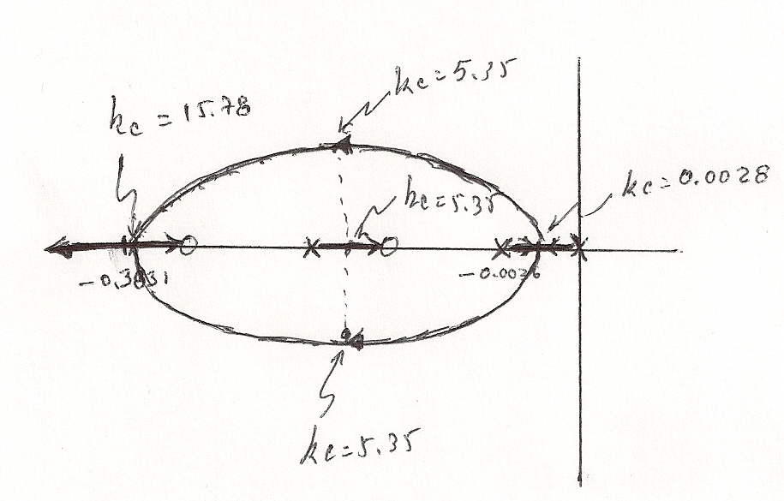

1. The characteristic equation can be rewritten as

Substituting we get

The roots of this polynomial are -0.1457±j0.1185 and -0.1447. They are marked in the root locus above. Note that all roots have the same real value so the system will be the fastest possible; as per the overshoot the complex conjugate pair results in a damping factor , with negligible overshoot.

**42.**



The MATLAB M-file is:

num1=250;

num2=[1 1.2 12500];

num = conv(num1, num2);

den=[1 8.1 62003 31250];

G=tf(num, den);

rlocus(G)

pause

K=0:0.1:5;

rlocus(G,K)

sgrid(0.4,0.2)

axis([-50,0.5,100,250]);

pause

for i=1:1:3;

[K,P]=rlocfind(G)

end

T=260*feedback(K*G,1)

step(T)

grid;

The MATLAB full root-locus obtained is shown below. After a few attempts, a step response with an overshoot of 14.6% was achieved. The figure, shown below the root locus, illustrates the step-response obtainedwith all of the requested important characteristics marked on it.





This output response was obtained at

K =

3.1319

P =

1.0e+02 *

-7.2280 + 0.0000i

-0.3414 + 1.1144i

-0.3414 - 1.1144i

T =

2.036e05 s^2 + 2.443e05 s + 2.545e09

--------------------------------------------------

s^3 + 791.1 s^2 + 6.294e04 s + 9.819e06

Continuous-time transfer function.

**SOLUTIONS TO DESIGN PROBLEMS**

**43.**

G(s) =



**a.** Root locus crosses the imaginary axis at ±j6.755 with 61.73K equal to 134892.8. Thus for oscillations, K = 2185.21.

**b.** From (a) the frequency of the oscillations is 6.755 rad/s.

**c.** The root locus crosses the 20% overshoot line at 6117.126o = - 2.736 + j5.34 with 61.73K = 23323.61. Thus, K = 377.83 and Ts = = = 1.462 seconds.

**44.**

**a**. There are two asymptotes with  and real axis intersection . To find the breakaway and break-in points, write  . The derivative of this expression is

. The denominators roots for this expression are 

The values of  at -2.5 and -4 are calculated from

 giving  and

 giving 

The root locus is:

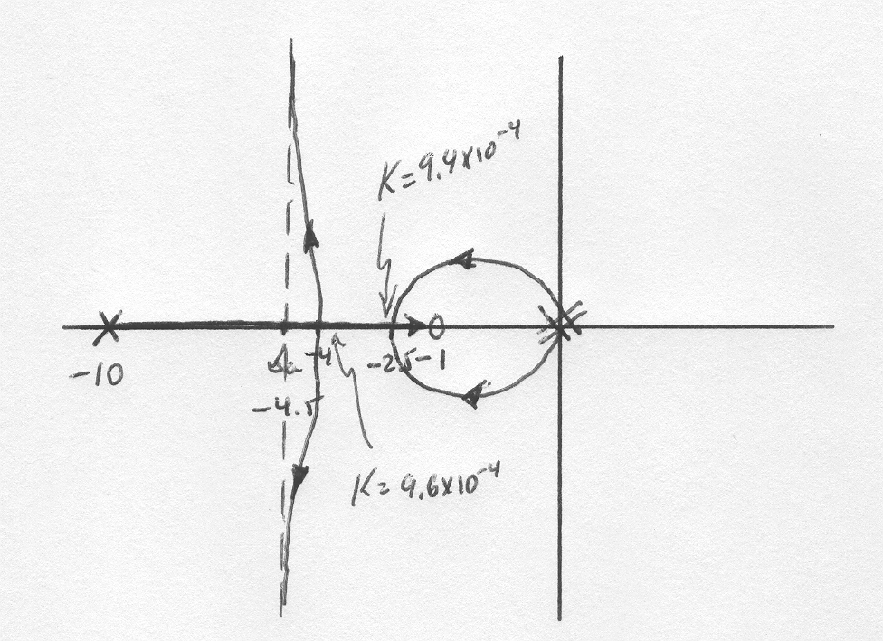

**b**. The line corresponding to must be at an angle so the line must lie along the points . The angle condition for the root locus must be satisfied. Namely 

A numerical search gives . So the root locus and the line intersect when . Then the value of  can be found from giving 

.**45.**

**a.** Using MATLAB and the Symbolic Math Toolbox, the open-loop expression that yields a root locus as a function of *N*2 is

0.2284x107*N*2 (*s*2 + 3.772e-05*s* + 66.27) (*s*2 + 49.99*s* + 8789)

*Gdt(s) =* ________________

*s*(*s*+45.12) (*s*2 + 4.893*s* + 8.777e04)

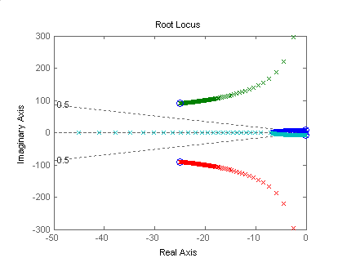

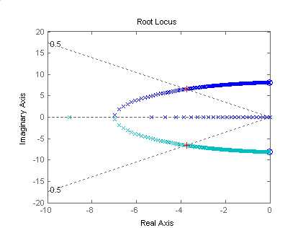

**Program:**

syms s N KLSS KHSS KG JR JG tel s

numGdt=3.92*N^2*KLSS*KHSS*KG*s;

denGdt=(N^2*KHSS*(JR*s^2+KLSS)*(JG*s^2*[tel*s+1]+KG*s)+JR*s^2*KLSS*[(JG*s^2+KHSS)*(tel*s+1)+KG*s]);

Gdt=numGdt/denGdt;

'Gdt in General Terms'

pretty(Gdt)

'Values to Substitute'

KLSS=12.6e6

KHSS=301e3

KG=668

JR=190120

JG=3.8

tel=20e-3

numGdt=3.92*N^2*KLSS*KHSS*KG*s;

numGdt=vpa(numGdt,4);

denGdt=(N^2*KHSS*(JR*s^2+KLSS)*(JG*s^2*[tel*s+1]+KG*s)+JR*s^2*KLSS*[(JG*s^2+KHSS)*(tel*s+1)+KG*s]);

denGdt=vpa(denGdt,4);

'Gdt with Values Substituted'

Gdt=numGdt/denGdt;

pretty(Gdt)

Gdt=expand(Gdt);

Gdt=vpa(Gdt,4);

'Gdt Different Form 1'

pretty(Gdt);

denGdt=collect(denGdt,N^2);

'Gdt Different Form 2'

Gdt=collect(Gdt,N^2);

pretty(Gdt)

[numGdt,denGdt]=numden(Gdt);

numGdt=numGdt/0.4349e10;

denGdt=denGdt/0.4349e10;

denGdt=expand(denGdt);

denGdt=collect(denGdt,N^2);

Gdt=vpa(numGdt/denGdt,4);

'Gdt Different Form 3'

pretty(Gdt)

'Putting into Form for RL as a Function of N^2 using previous results'

numGH=[1 49.99 8855 3313 582400];

denGH=[41.87 2094 0.3684e7 0.1658e9 0];

denGH=denGH/denGH(1)

GH=tf(numGH,denGH)

GHzpk=zpk(GH)

'Zeros of GH'

rootsnumGH=roots(numGH)

'Poles of GH'

rootsdenGH=roots(denGH)

K=0:1:10000;

rlocus(GH,K)

sgrid(0.5,0)

pause

axis([-10,0,-20,20])

[K,P]=rlocfind(GH)

**Computer response:**

ans =

Gdt in General Terms

98 2 / 2 2 2

-- N KLSS KHSS KG s / (N KHSS (JR s + KLSS) (JG s (tel s + 1) + KG s)

25 /

2 2

+ JR s KLSS ((JG s + KHSS) (tel s + 1) + KG s))

ans =

Values to Substitute

KLSS =

12600000

KHSS =

301000

KG =

668

JR =

190120

JG =

3.8000

tel =

0.0200

ans =

Gdt with Values Substituted

16 2 /

.9931 10 N s / (301000.

/

2 2 8 2

N (190100. s + .1260 10 ) (3.800 s (.02000 s + 1.) + 668. s)

13 2 2

+ .2396 10 s ((3.800 s + 301000.) (.02000 s + 1.) + 668. s))

ans =

Gdt Different Form 1

16 2 / 10 2 5 12 2 4 14 2 3

.9931 10 N s / (.4349 10 N s + .2174 10 N s + .3851 10 N s

/

14 2 2 16 2 12 5 13 4

+ .1441 10 N s + .2533 10 N s + .1821 10 s + .9105 10 s

17 3 18 2

+ .1602 10 s + .7212 10 s )

ans =

Gdt Different Form 2

16 2 / 10 5 12 4 14 3

.9931 10 N s / ((.4349 10 s + .2174 10 s + .3851 10 s

/

14 2 16 2 18 2 12 5

+ .1441 10 s + .2533 10 s) N + .7212 10 s + .1821 10 s

13 4 17 3

+ .9105 10 s + .1602 10 s )

ans =

Gdt Different Form 3

7 2 /

.2284 10 N s / (

/

5 4 3 2 2

(1.000 s + 49.99 s + 8855. s + 3313. s + 582400. s) N

9 2 5 4 7 3

+ .1658 10 s + 41.87 s + 2094. s + .3684 10 s )

ans =

Putting into Form for RL as a Function of N^2 using previous results

denGH =

1.0e+006 *

Columns 1 through 4

0.0000 0.0001 0.0880 3.9599

Column 5

0

Transfer function:

s^4 + 49.99 s^3 + 8855 s^2 + 3313 s + 582400

--------------------------------------------

s^4 + 50.01 s^3 + 8.799e004 s^2 + 3.96e006 s

Zero/pole/gain:

(s^2 + 66.27) (s^2 + 49.99s + 8789)

---------------------------------------

s (s+45.12) (s^2 + 4.893s + 8.777e004)

ans =

Zeros of GH

rootsnumGH =

-24.9950 +90.3548i

-24.9950 -90.3548i

-0.0000 + 8.1404i

-0.0000 - 8.1404i

ans =

Poles of GH

rootsdenGH =

1.0e+002 *

0

-0.0245 + 2.9624i

-0.0245 - 2.9624i

-0.4512

Select a point in the graphics window

selected_point =

-3.8230 + 6.5435i

K =

51.5672

P =

-21.1798 +97.6282i

-21.1798 -97.6282i

-3.8154 + 6.5338i

-3.8154 - 6.5338i

**b.** From the computer response, *K* = 0.2284x107*N*2  = 49.6. Therefore, N is approximately 5/1000.

**46.**

1. The characteristic equation is given by:

or

The Routh table is

|  |  |  |  |
| --- | --- | --- | --- |
|  |  | 3 | 1 |
|  | 2 | 2 |  |
|  |  | 1 |  |
|  |  |  |  |
| 1 | 1 |  |  |

Clearly for closed loop stability .

**b**. There is no locus on the real axis, and no asymptotes. The root locus starts at the loci of the complex poles and ends at the zeros in the origin:



**47.**

% Parameters

Jl=10;Bl=1;k=100;Jm=2;Bm=0.5;a=0.25;%a is the location of the zero

%numerator and denominator of the open loop transfer function

numo=k*[1 a];

deno=[Jl*Jm (Jl*Bm+Jm*Bl) (k*(Jl+Jm)+Bl*Bm) k*(Bl+Bm) 0];

syso=tf(numo,deno);

%Pole-Zero map for the open loop transfer function

pzmap(syso);

%Root Locus

rlocus(syso);axis([-1 0 -0.3 0.3]);

zgrid(0.707,[]); %grid for zeta=0.707 for approx. 5% overshoot

[KD,poles]=rlocfind(syso);

%Choose the appropriate location of the poles in the window and multiply the factor by the open loop

%transfer function

syso=KD*syso;

%Close the loop

sysc=feedback(syso,1);

figure;

%Obtain the response

step(sysc)



Select a point in the graphics window

selected_point =

-0.1031 + 0.0978i



Note the 5 % overshoot specified.

**48.**

**Front Panel**

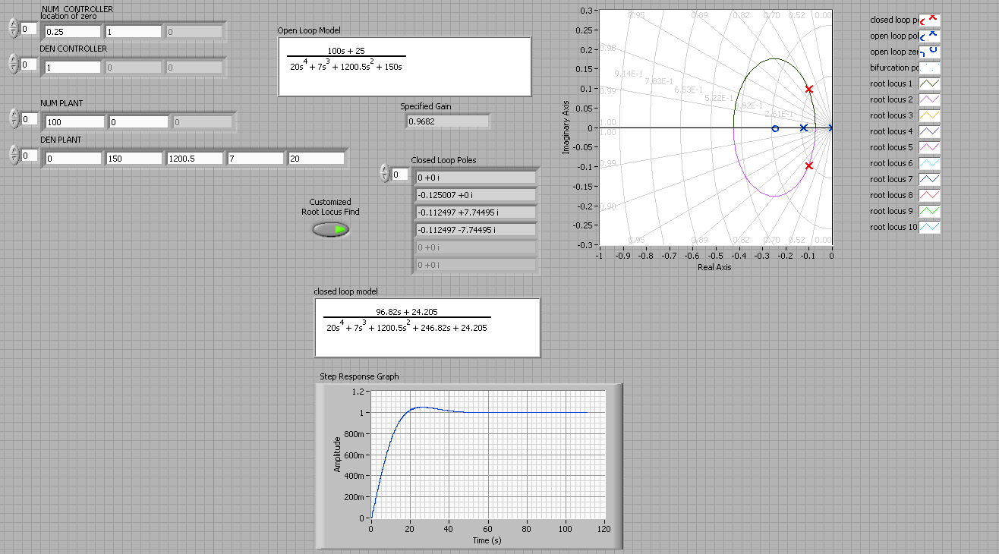

**Block Diagram**

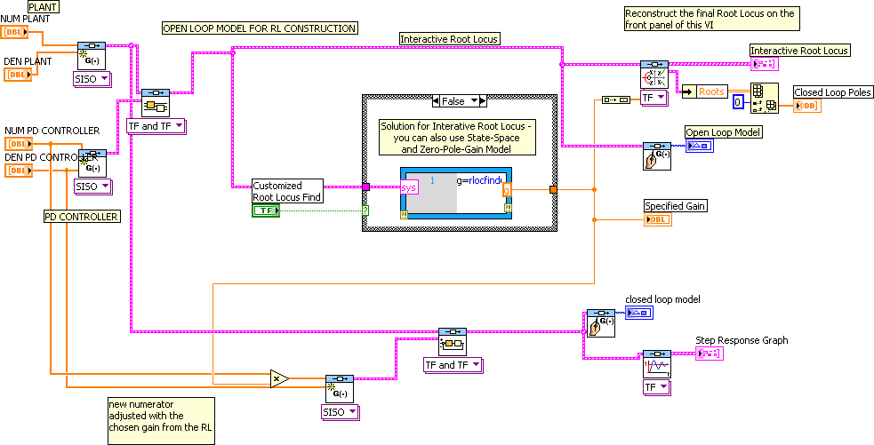

**Details of the Case Structure**

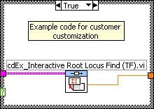 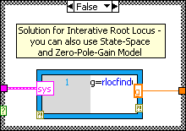

**49.**

The following MATLAB M-file was written to plot the root locus for the system and to find the required-above operational parameters and functions:

numg = poly ([-0.071-6.25i -0.071+6.25i]);

deng = poly ([-0.047 -2 -0.262+5.1i -0.262-5.1i]);

G = tf(numg, deng);

rlocus(G);

pos=(16);

z=-log(pos/100)/sqrt(pi^2+(log(pos/100))^2);

sgrid(z,0)

title(['Root Locus with ', num2str(pos), ' Percent Overshoot Line for Synchronous Machine with Te = 0.5 sec'])

[K1,p]=rlocfind(G);

pause

K=0.936*K1;

T=feedback(K*G,1); %T is the closed-loop TF of the system

T=minreal(T);

step(T);

grid



**Root Locus with 16% Overshoot Line for Synchronous Machine**

1. The gain at which the system becomes marginally stable is:

*K* = 7.1045

1. The closed-loop poles, *p*, and transfer function, *T*(s), corresponding to a 16% overshoot are:

p = -0.2300 + 4.9446i

-0.2300 - 4.9446i

-1.0555 + 1.8634i

-1.0555 - 1.8634i

|  |  |
| --- | --- |
| *T* (s) *=* | 2.633 s^2 + 0.3739 s + 102.9  -------------------------------------------------------- |
| s^4 + 2.571 s^3 + 29.88 s^2 + 53.81 s + 105.3 |

1. The coordinates of the point selected on the root-locus were: -1.0557 + 1.8634i and the corresponding unit-step response, with * (t)* inp.u, was found.
2. MATLAB was used to plot that unit-step response and to note on that curve the required characteristics:



**50.**

**a**. The open loop transfer function can be described as:

The system has open loop poles at -0.0004, -0.9625 and -2.4101; open loop zeros at 0, -0.001, -1.3178

Since the number of open loop poles equals the number of open loop zeros there are no asymptotes.

To calculate the breakaway points we form which in this case is

Simplifying this results in

The solutions for this equation are -1.129±j4.618, -0.0007, -0.00005033 the latter two points being on the root locus.

From

and similarly for s=-0.0007, .

The sketch for the roots locus is:

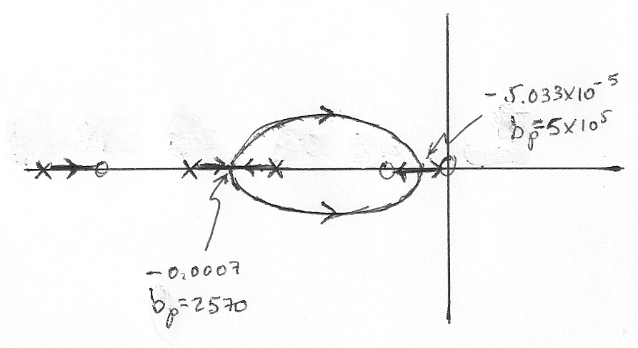

**b**. The system is overdamped when and .

**c**. The system is critically damped when and

**d**. The system is underdamped when .

**e**. For larger values of the system has dominant closed loop poles very close to the jω axes.

**51.**

**a**.

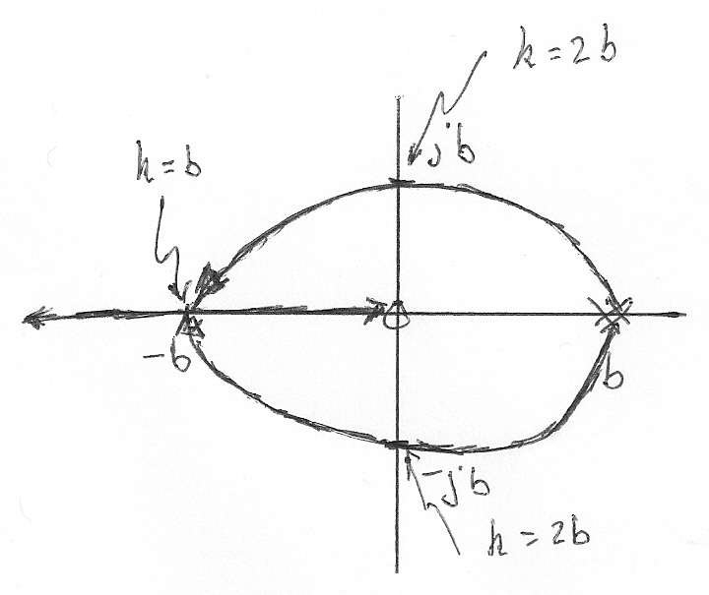

The breakaway points are found from or

Which can be simplified to , from which , only the negative solution being on the root locus. To find the value of gain at this point we use the characteristic equation

From which we get that at the breakaway point .

**b**. The characteristic equation can be written as from the quadratic equation solution is can be readily observed that the roots will be in the left half plane as long as .

1. From the quadratic equation it can also be observed that the two roots will be complex when . At this point the characteristic equation becomes the roots are so the system will oscillate with a frequency of b rad/sec.

**52.**

Substituting the values given for the capacitance, inductances and resistances and reducing the internal loops to single blocks, yields the following feedback loop:



The transfer function of this feedback loop is:

 =



The MATLAB M-file is:

numg = [1017637.5 2238802500];

deng1 = [1 219.9];

deng2 = [1 114.4 17653251.48];

deng = conv(deng1, deng2);

G = tf(numg, deng);

rlocus(G);

title('Full Root Locus for Grid Connected VSC')

pause

axis ([-300, 0, -50, 5000]);

z=0.012;

sgrid(z,0)

title('Root Locus Zoomed-in for Dominant Poles at a 0.012 Damping Line')

[K1,p]=rlocfind(G);

pause

K = K1;

T=feedback(K*G,1); %T is the closed-loop TF of the system

T=minreal(T);

step(208*T);

grid

ylabel('Output Voltage of the VSC, Va(t), in volts')

title('Output Response for a Grid Connected VSC')

The full root-locus obtained is shown below. The close-up of that locus (from -300 to 0 on the real axis and from -50 to 5000 on the imaginary axis) follows. From that close-up, *K* and the coordinates of the dominant poles corresponding to *ζ* = 0.012 were found to be:

Selected_point = -5.0590e+01 + 4.2172e+03i; *K* = 0.1278;

p = 1.0e+03 *

-0.0500 + 4.2169i

-0.0500 - 4.2169i

-0.2344 + 0.0000i

The corresponding closed-loop transfer function is:

1.3e05 s + 2.86e08

T = ---------------------------------------

s^3 + 334.3 s^2 + 1.781e07 s + 4.168e09

The figure, shown below the close-up, illustrates the step-response obtainedat that value of the gain (with all of the requested important characteristics marked on it) when a step input, *r(t)=* 208 *u*(t), volts, was applied at t = 0.





**53.**

1. The open loop transfer function is



There are two asymptotes with a real axis intersection given by and angles . For , and for , .

To obtain the breakaway points let



And calculate and solve



Giving  with only the latter in the root locus. The value of K at is given by:



It was already found in Problem 6.? That the system is closed loop stable for . The root locus is:

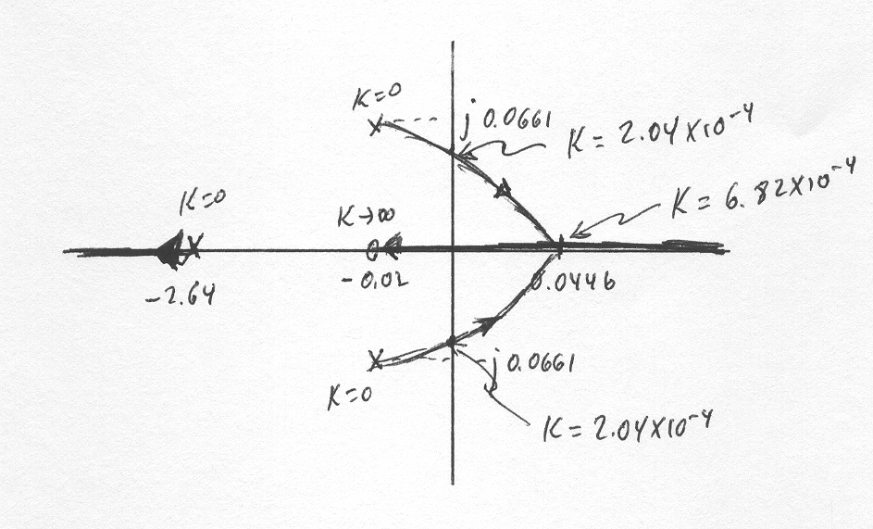

**b.** Now the open loop transfer function is:



There are two asymptotes with a real axis intersection as in part a. but with angles . For , and for  , .

The breakaway point calculation is similar to the one in part a. giving  with the first two points in the root locus.

The value of K at is given by:



The value of K at is given by:



We use Routh-Hurwitz to show that the system is closed loop stable for all . The characteristic equation is:



or



or



The Routh Array is:

|  |  |  |
| --- | --- | --- |
|  |  |  |
|  |  |  |
|  |  |  |
| 1 |  |  |

It can easily be verified that all the entries in the first column are positive for all .

The root locus is:

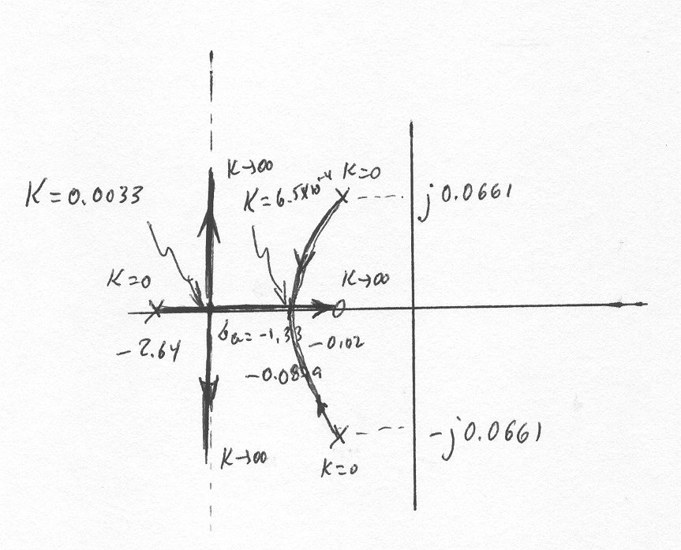

**54.**

1. With the speed controller configured as a proportional controller [*KI*SC*=* 0 and *G*SC(s) *= KP*SC], the open-loop transfer function is: .

Expanding the denominator of this transfer function, gives: . Solving for the roots shows that there are two open-loop poles: – 0.5858 and – 0.0163. Thus, the open-loop transfer function may be re-written as:

 (1)

In this equation:  (2)

The following MATLAB M-file was written to plot the root locus for the system and to find the value of the proportional gain, *K1*, at the breakaway or break-in points.

numg = [1 0.6];

deng = poly ([-0.0163 -0.5858]);

G = tf(numg, deng);

rlocus(G);

pos=(0);

z=-log(pos/100)/sqrt(pi^2+(log(pos/100))^2);

sgrid(z,0)

title(['Root Locus with ', num2str(pos) , ' Percent Overshoot Line'])

[K1,p]=rlocfind(G);

pause

T=feedback(K1*G,1); %T is the closed-loop TF of the system

T=minreal(T);

step(T);

axis ([0, 8, 0, 1]);

grid

The root locus shown below was obtained. Using MATLAB tools, the gain at the break-in point was found to be larger and, hence, would yield a faster closed-loop unit-step response. The following repeated real poles were found, which indicated that the step response is critically damped: p = *-* 0.6910, *-* 0.6910. These poles corresponded to: K1 = 0.78 (which corresponds to *KP*SC = 42.54). The closed-loop transfer function, T(s), was found to be:

0.78 s + 0.468

T(s) = -----------------------

s2 + 1.382 s + 0.4775

Therefore, it was used to find the closed-loop transfer function of the system, to plot its unit-step response, c(t), shown below, and to find the rise-time, Tr, and settling time, Ts.





As could be seen from the graph, these times are:

Tr = 2.69 sec and Ts = 4.69 sec

1. When integral action was added (with *KI*SC/*KP*SC = 0.4), the transfer function of the speed controller became:  and the open-loop transfer function obtained was:



Where  or 

The following MATLAB M-file was written to plot the root locus for the system and to find the gain, *K1*, which could result in a closed-loop unit-step response with 10% overshoot.

numg = poly ([-0.4 -0.6]);

deng = poly ([0 -0.0163 -0.5858]);

G = tf(numg, deng);

rlocus(G);

pos=(10);

z=-log(pos/100)/sqrt(pi^2+(log(pos/100))^2);

axis ([-1, 0, -0.5, 0.5]);

sgrid(z,0)

title(['Root Locus with ', num2str(pos) , ' Percent Overshoot Line'])

[K1,p]=rlocfind(G);

pause

T=feedback(K1*G,1); %T is the closed-loop TF of the system

T=minreal(T);

step(T);

axis ([0, 20, 0, 1.5]);

grid

The root locus shown below was obtained. Using MATLAB tools, the gain at the point selected on the locus (- 0.275 + j 0.376) was found to be K1 = 0.526 (which corresponds to *KP*SC = 28.7). The corresponding closed-loop transfer function, *T(s)*, is:



T(s) has the closed-loop poles: p = *–* 0.580, *–* 0.275 ± j 0.376 and zeros at – 0.4 & *–* 0.6. Thus, the complex conjugate poles are not dominant, and hence, the output response, c(t), obtained using MATLAB, does not match that of a second-order underdamped system. Note also that the settling time, Ts = 15 sec, , the rise time, Tr = 2 sec, the peak time, Tp = 5.03 sec, and the overshoot is 24.5% (higher than the 10% corresponding to the dominant poles).





It should be mentioned that since we applied 1 volt-unit-step inputs (as compared to 4 volts in the Hybrid vehicle progressive problem in Chapter 5) in both parts (a) and (b) above, we should not be surprised that the final (steady-state) value of output voltage of the speed transducer was 1 volt, which corresponds to a change in car speed of only 5 km/hr.

**55.**

1. After substitution of the delay approximation the resulting open loop transfer function is:



There are 2 asymptotes, using equation 8.66 we obtain that the angles are  and . The intersection with the real axis (although irrelevant given the asymptote angles) is 

1. The break-in and breakaway points can be obtained from  where  ,  ,  and  . After substituting and simplifying one gets . This polynomial has solutions at . Only first root is in the root locus so it’s a break-in point.
2. The characteristic equation is:



or



The corresponding Routh array is:

|  |  |  |
| --- | --- | --- |
|  |  |  |
|  |  |  |
|  |  |  |
| 1 |  |  |

It is readily seen that the fourth row entry is positive as long as . The third row entry is positive as long as  . Therefore the range for closed loop stability is .

1. The system will oscillate when . At this point the auxiliary equation becomes:



Equating to zero the equation has a solution at . So the oscillation frequency is 0.025 rad/sec.

The resulting root locus is shown below:

